Author Guide

1. General requirements
- The length of the article: 4000-8000 words.
- File format: Microsoft Word (.docx).
- Page size: A4
- Margins: 2.5 cm on all sides.
- Font: Times New Roman.
- Font size: 12 pt.
- Line spacing: 1 pt.
- Paragraph indentation: 0.8 cm.
- Alignment: justified.
- Page numbering: bottom right.

2. Article structure
1. The title of the article is 14 pt, bold, centered. In Kazakh, Russian and English.
2. Author(s): full name, academic degree and title, place of work, country, ORCID, e-mail (no more than 5 authors).
3. Abstract: 200-250 words. In Kazakh, Russian and English.
4. Keywords: 5 words. In three languages.
5. Main text:
- Introduction
- Method (Materials and methods)
- Results and their discussion
- Conclusion
6. Acknowledgements – if necessary.
7. Financing statement.
8. Conflict of Interest.
9. Author Contributions.
10. Data availability.
11. Open Access and Copyright
12. The list of references is in the style of APA 7.

3. Tables and figures
- Tables: numbered, the name is written on top (Table 1 – The results of the study).
- Figures: numbered, the name is written at the bottom (Figure 1 – Semantic correspondence of sounds).
- Format: JPEG/PNG images (at least 300 dpi), tables inside Word.
- Location: close to the place of application inside the text.
- Reference: must be stated in the text.

4. References (APA 7 style)
- Link inside the text: (Author, year). For example: (Sapir, 1929); (Khusainov, 1988).
- Direct quote:
Short (up to 40 words): "...text..." (Author, year, p. 45).
Long (more than 40 words): a separate paragraph, with a left indentation, without quotation marks.
- Number of references: at least 15, there must be Scopus/WoS articles from the last 5 years (at least 5 sources).
- List: alphabetically.
- Kazakh and Russian literature: transliterated and translated into English in parentheses.

5. Scientific ethics
- Originality: the article should not be previously published or submitted to another journal.
- Plagiarism: It is checked in the anti-plagiarism system (70% less).
- Ethics: permission from the ethics committee or voluntary consent for research involving humans.
6. Information about the authors. At the end of the article, after the list of references, information about the authors in English is provided. Information includes: last name, first name, patronymic (in full), academic degree, academic title, position, place of work (institution), as well as a brief description of the field of scientific interests of the author.
Example:
Name Surname – Candidate of Pedagogical Sciences, Associate Professor at “Bolashaq” Academy.
7. Manuscript Submission Requirements
Authors must submit two versions of the manuscript:
The first file should contain complete author information (full name, academic degree, academic title, position, affiliation, ORCID, and contact details).
The second file should be an anonymized version prepared for peer review. This version must not contain author names, affiliations, ORCID identifiers, contact information, or any other details that could reveal the identity of the author(s). The anonymized version is used to ensure an independent and unbiased peer-review process.

Article Title (14 pt)

Full name of the author^{1*}, full name of the Author²

¹Оrganization, Department, City, Index, country. E-mail: example@mail.com; ORCID: https://orcid.org/xxxx
²Оrganization, Department, City, Index, country. E-mail: example2@mail.com; ORCID: https://orcid.org/yyyy

Abstract (English)
Here you write the abstract in English (200–250 words).
Keywords: word1, word2, word3, word4, word5.

Мақала атауы (14 pt)

Автордың толық аты-жөні^{1*}, Автордың толық аты-жөні²

¹Ұйым, кафедра, қала, индекс, ел. E-mail: example@mail.com; ORCID: https://orcid.org/xxxx
²Ұйым, кафедра, қала, индекс, ел. E-mail: example2@mail.com; ORCID: https://orcid.org/yyyy

Аннотация (қазақша)
Мұнда 200–250 сөздік қазақ тіліндегі аннотация жазылады.
Кілт сөздер: сөз1, сөз2, сөз3, сөз4, сөз5.

Заголовок статьи (14 pt)

Полное имя автора^{1*}, полное имя автора²
¹Организация, кафедра, город, индекс, страна. E-mail: example@mail.com; ORCID: https://orcid.org/xxxx
²Организация, кафедра, город, индекс, страна. E-mail: example2@mail.com; ORCID: https://orcid.org/yyyy

Аннотация (орысша)
Здесь пишется аннотация на русском языке (200–250 слов).
Ключевые слова: слово1, слово2, слово3, слово4, слово5.

1. Introduction
This section reveals the relevance of the research topic. The current state of the scientific problem is described, that is, it briefly describes how this issue has been considered in domestic and foreign studies. It explains why the article is important, which is theoretical and practical. The purpose and objectives of the study are clearly indicated at the end of the section.

2. Method (Materials and methods)
This section describes how the research was conducted. It indicates which material or source was used, the number and description of participants (if there is an experiment), the methods and techniques used (survey, content analysis, statistical processing, etc.). It also indicates the equipment used in the study, programs (SPSS, Jamovi, Excel, etc.) and ethical requirements (voluntary consent, permission).

3. Results and their discussion
This section presents the data obtained during the study. The main results can be displayed through tables and figures. Each result is clearly explained and its meaning is revealed. A comparison is made with previous studies, similarities and differences are indicated. The author discusses the confirmation or denial of his hypothesis.

Table 1. The results of the study
(must be stated in the text)

Ұғым |  | N |  | Орташа мәні |  | Медиана |  | SD |  | SE
Қаз |  | 73 |  | 5.44 |  | 5 |  | 3.50 |  | 0.410
Аққу |  | 54 |  | 1.70 |  | 1.00 |  | 1.70 |  | 0.231
Қарлығаш |  | 58 |  | 3.12 |  | 2.00 |  | 2.69 |  | 0.353
Қыран |  | 78 |  | 7.13 |  | 9.00 |  | 3.30 |  | 0.374

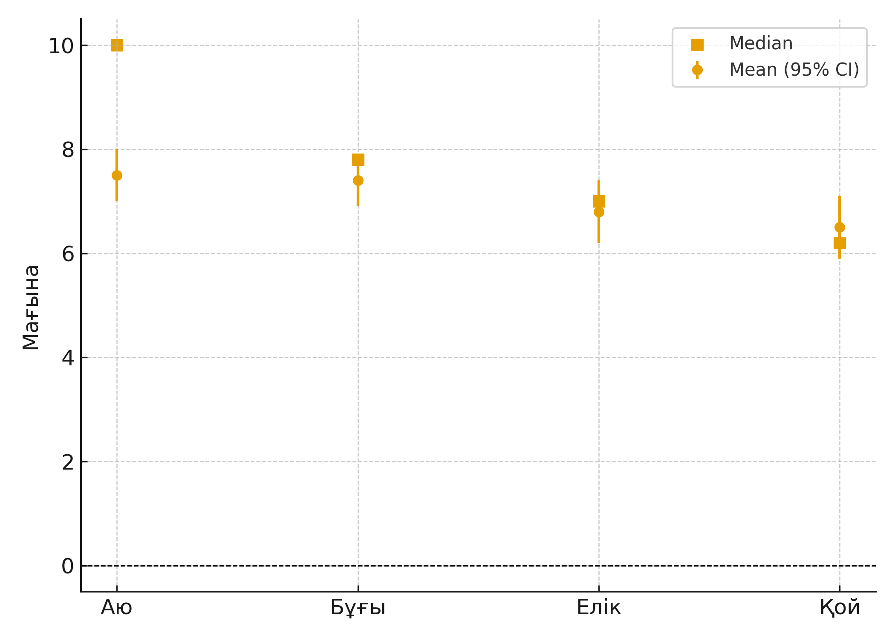
Figure 1. Semantic correspondence of sounds
(must be stated in the text)

4. Conclusion
This section summarizes the main findings of the study. The scientific novelty and practical significance of the main results are noted. It will also be suggested in which areas additional research can be conducted in the future.

Acknowledgement
If necessary, the persons and organizations to whom gratitude is expressed are indicated.

Financing statement
For example: This study was funded under a grant from the Ministry of Science and Higher Education of the Republic of Kazakhstan (grant no. ...).

Conflict of interests
The author(s) declares that there is no conflict of interest.

Author contributions
For example: Author 1 - concept, methodology; Author 2 - data analysis; Author 3 - conclusion and editing.

Data availability
The data used in this article is available at the request of the authors.

Appendix
The appendix is an optional section that contains additional data that complements the main text. Here, for example, a detailed description of the experience is provided, information that is burdensome to the main text, but important for understanding and repeating the research. The appendix also contains a complete version of the tables and figures summarized in the main text, or mathematical proofs. All applications are subject to a mandatory link inside the text. The tables and figures in the appendix are numbered with a special mark: for example, Table A1, Table A2 or Figure A1, Figure A2. This shows that they are separated from the main text and makes the structure of the article understandable.

References (APA 7)

Journal articles
Формат:
Автор, А. А. (Год). Название статьи. Название журнала, Объем (Номер), страницы. https://doi.org/xxxx
Примеры:
Sapir, E. (1929). A study in phonetic symbolism. Journal of Experimental Psychology, 12(3), 225–239. https://doi.org/10.1037/h0070931

Books
Format:
Author, A. A. (Year). The title of the book. Publishing house.
Examples:
Jakobson, R. (1965). Selected writings: Phonological studies. Mouton.
Lakoff, G., & Johnson, M. (1980). Metaphors we live by. University of Chicago Press.

Book chapters
Format:
Author, A. A. (Year). The title of the chapter. Inside is the Editor (Ed.), the title of the book (pages). Publishing house.
Example:
Saussure, F. de. (1916). Nature of the linguistic sign. In C. Bally & A. Sechehaye (Eds.), Course in general linguistics (pp. 65–70). McGraw-Hill.

References in Kazakh, Russian and etc. (transliteration and translation)
Format:
Author, A. A. (Year). Transliterated name [English translation]. City: Publishing house.
Examples:
Sartkozhauly, Q. (2007). Orkhon muralary [Orkhon heritage]. Astana: El-shezhire.

Dissertation
Format:
Author, A. A. (Year). The title of the dissertation is [Doctoral thesis, University name]. Repository/URL.
Example:
Brown, L. (2019). Phonological development in bilingual children [Doctoral dissertation, University of Oxford]. Oxford Digital Repository.

Web-site / online document
Format:
Author/Organization. (Year, month, day). The name of the document. The name of the website. URL:
Example:
UNESCO. (2023, March 12). Language endangerment in Central Asia. UNESCO. https://unesco.org/language

The list of references is provided alphabetically..
- Akhundov, A. (1995). Turkic languages and symbolic sound structures. Baku: Elm.
- Dingemanse, M. (2012). Advances in the cross-linguistic study of ideophones. Language and Linguistics Compass, 6(10), 654–672. https://doi.org/10.1002/lnc3.361
- Dingemanse, M., Blasi, D. E., Lupyan, G., Christiansen, M. H., & Monaghan, P. (2015). Arbitrariness, iconicity, and systematicity in language. Trends in Cognitive Sciences, 19(10), 603–615. https://doi.org/10.1016/j.tics.2015.07.013
- Hinton, L., Nichols, J., & Ohala, J. J. (Eds.). (1994). Sound symbolism. Cambridge University Press.
- Jakobson, R. (1965). Selected writings: Phonological studies. Mouton.
- Johansson, N., Anikin, A., Carling, G., & Holmer, A. (2020). The typology of sound symbolism: Defining macro-concepts via their semantic and phonetic features. Linguistic Typology, 24(2), 253–310. https://doi.org/10.1515/lingty-2020-2050
- Khusainov, K. Sh. (1988). Qazaq tilindegi fonosemantikalyq qubylystar [Phonosemantic phenomena in the Kazakh language]. Almaty: Gylym.
- Lakoff, G., & Johnson, M. (1980). Metaphors we live by. University of Chicago Press.
- Sapir, E. (1929). A study in phonetic symbolism. Journal of Experimental Psychology, 12(3), 225–239. https://doi.org/10.1037/h0070931
- Sartkozhauly, Q. (2007). Orkhon muralary [Orkhon heritage]. Astana: El-shezhire.

Information about the authors
Name Surname – Candidate of Pedagogical Sciences, Associate Professor at “Bolashaq” Academy.

Transliteration + English translation is required in Kazakh/Russian references.
If there is a DOI, you must specify it.
The APP requirement is a minimum of 15 sources, there must be Scopus/WoS articles from the last 5 years (at least 5 sources).

